**KuzQuality Meth Cooking**

Official Recipe + Guide

(FiveM)

<https://kuzquality.com/package/6465705>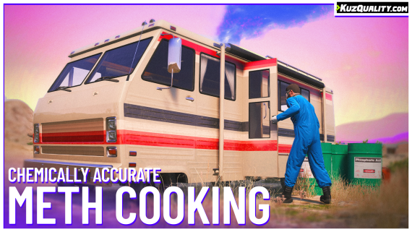

# Chapter 1: Item collection

To start the meth cooking process. You will need to have all the necessary items in your inventory at the time of entering the van. The items are as follows:

* kq_meth_lab_kit
* kq_ammonia
* kq_acetone
* kq_ethanol
* kq_lithium (3x)
* kq_meth_pills

## Basic item collection

The following items can simply be picked up from the game world. Check your game map or config.lua file to find their individual locations.

* kq_meth_lab_kit
* kq_acetone
* kq_ethanol
* kq_lithium
* kq_meth_pills

Some items will be guarded by the “guard” npc’s. You can configure them via the config.lua file.

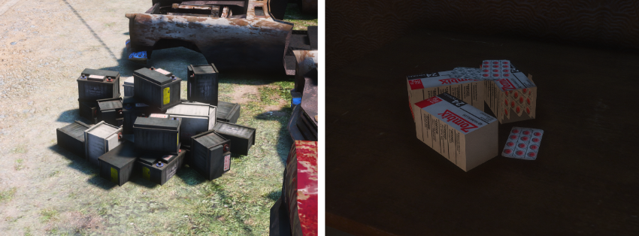

## Ammonia collection

Collecting ammonia has a slightly more advanced system.

Ammonia spawns in huge tanks, by default there are 4 tanks total. 3 at the humane labs and one secret tank at the docks. All this is configurable in the config.lua file

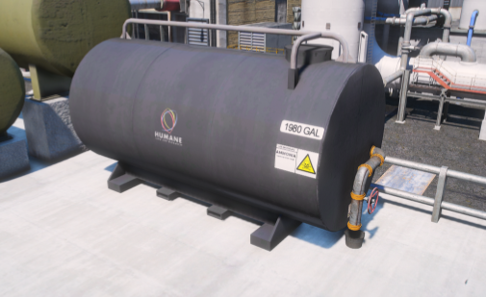

Now what’s special about these tanks?   
The ammonia tanks hold a limited amount of ammonia, making it a highly limited resource. You can define how much ammonia will be held in a tank at a time, and the corresponding respawn time. By default each tank holds 4 ammonia items and takes 20 minutes to refill.

The tanks will only start the refill timer once they’re fully empty. Meaning that if a player takes 3 out of 4 ammonia items, the tank will not refill and only hold 1 item until another player takes it which will trigger the refill cooldown.

# Chapter 2: Cooking vehicle

To start the cooking process. You will need a vehicle.

We have prepared a set of vehicles which allow you to cook meth in.

The following vehicles are:

* Journey Van (journey)
* Journey Van II (journey2)
* Camper (camper)

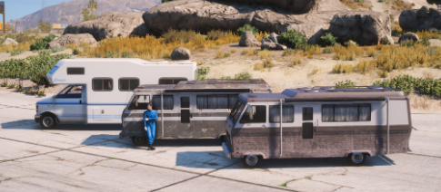

If you opted in to purchase our “Meth Lab Rumpos” addon pack. You can also use the custom Rumpos.

* Lab Rumpo 4x4 (kqrumpo)
* Lab Rumpo Sport (kqrumpo2)

If you have not yet purchased this addon, you can do so here: <https://kuzquality.com/package/6469568>

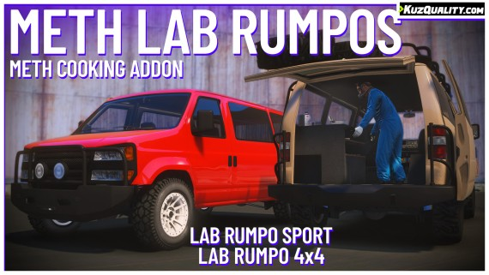

You will need to provide a method of getting these vehicles for your players yourself. We simply recommend putting them in one of your car stores. Alternatively you can rely on the players having to find them in the world.

# Chapter 3: Entering the vehicle

To enter a vehicle which has the ability to cook in. Simply stand next to the side door and press **F**.

On journey(s) this is the door on the left side of the vehicle. For the remaining vehicles such as the camper and rumpo(s) it’s the door on the right hand side of the vehicle.

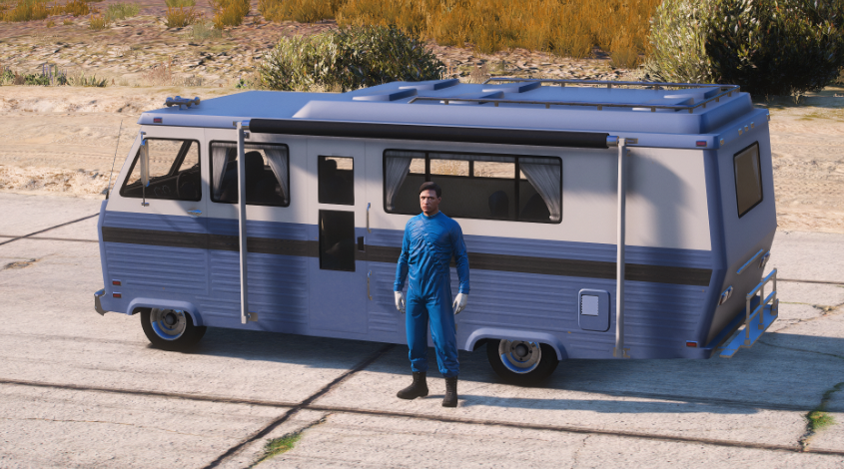

# Chapter 4: Preparing for cooking

As mentioned before. To start the cooking process correctly you will need to have all the required items in your inventory. If you do not have all the items, you will not have all the resources available on the cooking counter.

This is how your workstation should look like.

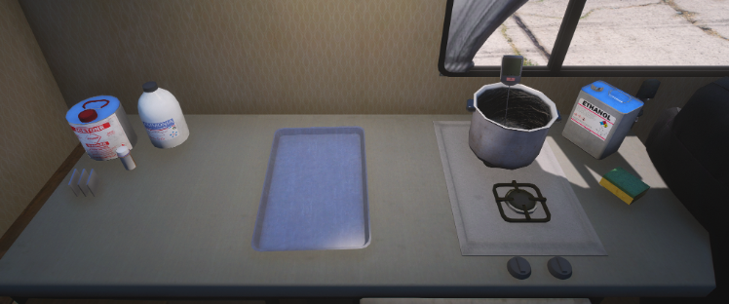

# Chapter 5: Systems explained

When in the cooking mode, you can freely drag and drop all the items on the counter.

You are able to pour all the liquids into the pot. The liquids will perform different reactions based on what else was added to the pot, and the liquid's temperature which is indicated on the thermometer inside the pot.

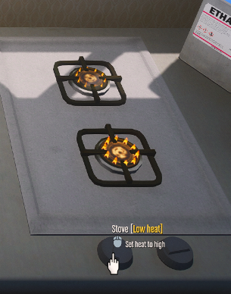

To control the temperature you will need to utilize our stove “device”.

Press on the hob dials to toggle between the modes

# Chapter 6: Recipe

The cooking recipe is quite freeform, as there is no hardcoded recipe. All “chemicals” will react with each other based on the temperature and other chemicals involved. We will guide you through the process of cooking meth. Mind that some steps may be marked as only necessary when using the highest difficulty setting in the config.lua

Intro: When we refer to the cooking temperature we are talking about the temperature defined in the config file (Config.recipe > cookingTemperature). By default this is 50

If even with this recipe you are having difficulties getting good quality meth. You can enable the debug mode in the config to get additional insight into what's happening during the cooking process. You can also try lowering the difficulty to make the process easier

### Step 1

Add the following ingredients into the pot (Again, the order does not matter)

* Acetone
* Ammonia
* Pseudoephedrine (pills)
* Lithium plate (1x)

### Step 2

Heat up the mixture to the cooking temperature.

At this point you will notice that the mixture has started reacting. This is the lithium inside the mixture being mixed in. When this happens, you will observe the temperature increase rapidly.

**Important:**

When cooking meth you always want the temperature to stay as close as possible to the cooking temperature. If your temperature gets too high (+- 20c more than the cooking temperature bad things will happen to your mixture)

It is necessary to keep your temperature between 50 and 70 degrees (Again, 50 here being the cooking temperature)

### Step 3

Now that lithium is reacting, the temperature is going up. You will need to as quickly as possible turn off the stove or move the pot off the flame so as not to increase the temperature further.

### Step 4

Wait until the lithium stops reacting and temperature drops back down to slightly above the cooking temperature. But do not let it drop too far below the cooking temperature as this will also cause the meth to become less pure.

Once the temperature is slightly above the cooking temperature (the closer to the cooking temperature the better)

You can add another lithium plate. The process will now repeat.

Repeat until all 3 lithium plates are added into the mixture

### Step 5

Keep the mixture between the cooking temperature and (cooking temperature + 20*)

*The leeway of how much over the cooking temperature you can get before ruining your meth is based on the config difficulty option.

Keep the mixture at that temperature until you see no more dense smoke coming out of your pot. A tiny bit of steam will always be coming out of the pot when its at a high temperature, you can ignore that.

### Step 6

Once the mixture stops smoking, let the it drop down below 40 degrees

### Step 7

Add ethanol and keep cold until the dense smoke stops coming out of the pot. When the smoke is coming out it means that the ethanol is still mixing with the substance.

### Step 8 *This step is only necessary when the difficulty is set to 8 or higher - skip otherwise

The ethanol will leave a bit of a trace. Which we will need to burn off to obtain meth of higher purity. Again, increase the mixture up to the cooking temperature for a few seconds. Again, here you will see when it's finished when the dense smoke stops coming out of the pot.

### Step 9

Let the mixture cool down to the lowest temperature it can get in the pot. Then pour it over to the tray.

### Step 10

Wait for the liquid meth to solidify within the tray. From here you will need a couple seconds. The script will automatically kick you out of the van and announce the purity of your meth.